W-12
YEAR 10 SCIENCE
EARTH AND SPACE SCIENCE
RESEARCH ACTIVITY

Due Date:

Task

Given below are a series of questions aimed at understanding more about the universe, our galaxy and solar system. You need to research information on each question. Record your information in a suitable format - dot point, brief notes, labelled diagram, etc. You will be tested on some or all of these questions, so be well prepared!

Internet Resources

You may find the following websites useful. There are many others as well - remember to select sites that are "reputable". e.g. Well known universities, astronomical societies, NASA, etc.

Metacrawler - a meta-search engine that looks in all other search engines.

http://www.metacrawler.com/

Trinity College Astronomy - very good links to many sites.

http://observatory.trinity.wa.edu.au/index.html

NASA - superb site for up to date information. Many good links as well.

http://www.nasa.gov/home/

Wikipedia - has useful information and good links on near-Earth asteroids.

http://en.wikipedia.org/wiki/Near-Earth_asteroid

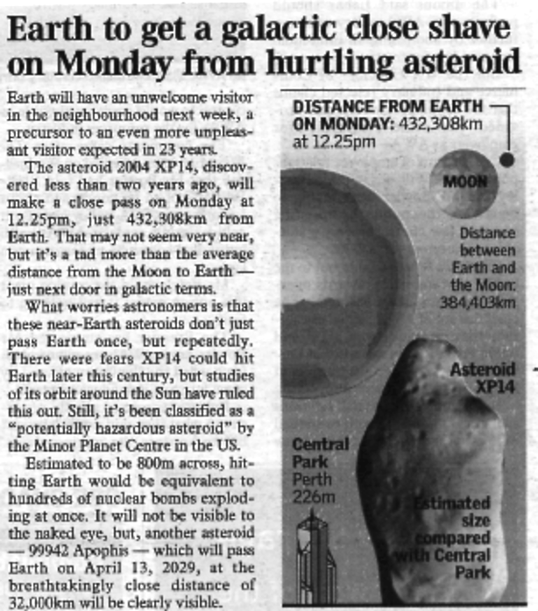
Questions

1. Earth had a near miss with a large asteroid on Monday 3/7/06 at 12.25 pm (Perth time). The article above
appeared in The West Australian newspaper. Astronomers are currently tracking many such objects, each on a
near-Earth orbit.

(a) Name 3-5 projects looking for near-earth asteroids.

(b) There are 3 different types of near-Earth objects - what are they and how do they differ?

(i)

(ii)

(iii)

(c) How many asteroids and objects are being tracked currently?

(d) Apart from the instance given in the article above, have there been any "close shaves" with objects just missing the Earth? Give data such as date, time, size, speed, distance away.

DATE | TIME | SIZE | SPEED | MISS DISTANCE

(e) Are we in danger from a collision in the near future? What do the experts and agencies predict?

2. (a) From where do asteroids and meteors come in our solar system?

(b) Why do they orbit so close to the Earth and other planets?

3. In Earth's recent history (50-300 million years), the surface has been hit by asteroids and meteors of varying size.

(a) List one impact that has occurred.

(b) Where and when did it occur?

(c) What was the size of the impact - usually given in equivalent units to nuclear bombs?

(d) What effects did it have? Was life in that area affected? Was there a worldwide effect?

•

•

•

•

•

(e) What evidence currently exists that indicates that the impact occurred?
e.g. Crater above ground or below sea, photographs from space, ground radar, etc.

4. There are competing theories on the origins of the universe - Creation, Steady State, Big Bang and Big Crunch
(Oscillating). Using only a few dot points for each, describe how each theory describes the formation and
evolution of the universe.

Creation

•

•

•

•

Steady State (Infinite Universe Theory)

•

•

•

•

Big Bang

•

•

•

•

Big Crunch (Oscillating)

•

•

•

•

More Useful Sites

http://www.aerospaceguide.net/nearearthasteroids.html

http://neo.jpl.nasa.gov/orbits/

http://impact.arc.nasa.gov/

http://whyfiles.org/106asteroid/2.html

http://sci.uncletom2000.com/creation.htm

http://en.wikipedia.org/wiki/Ultimate_fate_of_the_universe - Big_Crunch:_finite_time_and_lifespan

http://www.pbs.org/wgbh/evolution/extinction/dinosaurs/asteroid.html

Extra Notes

